1. Name - The Angiotensin II Receptor Type 1 (AT1R)

Structure of angiotensin II type I receptor (AT1R) nanobody antagonist AT118i4h32

1. PDB Id with structure – 7T83

**3-D structure of the receptor**

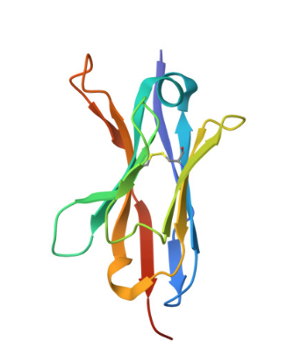

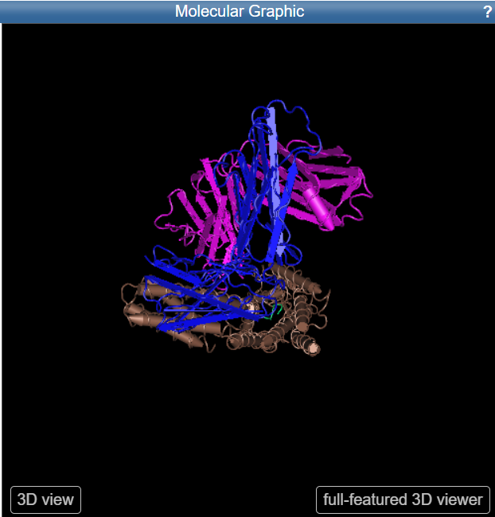

Image of the molecule in the document

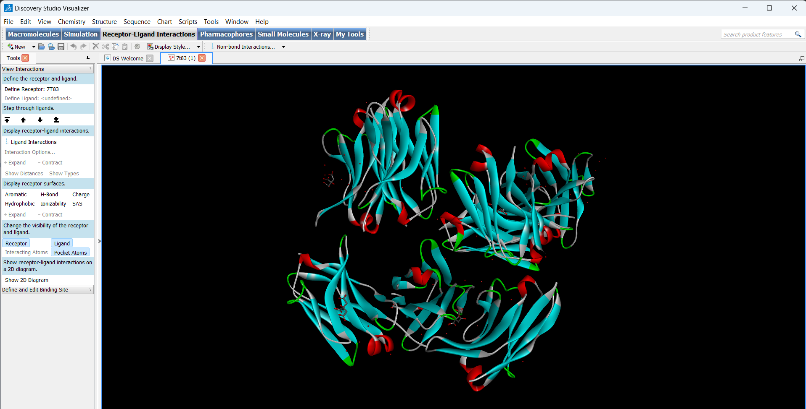

3.) List the interaction region, domain of the molecule

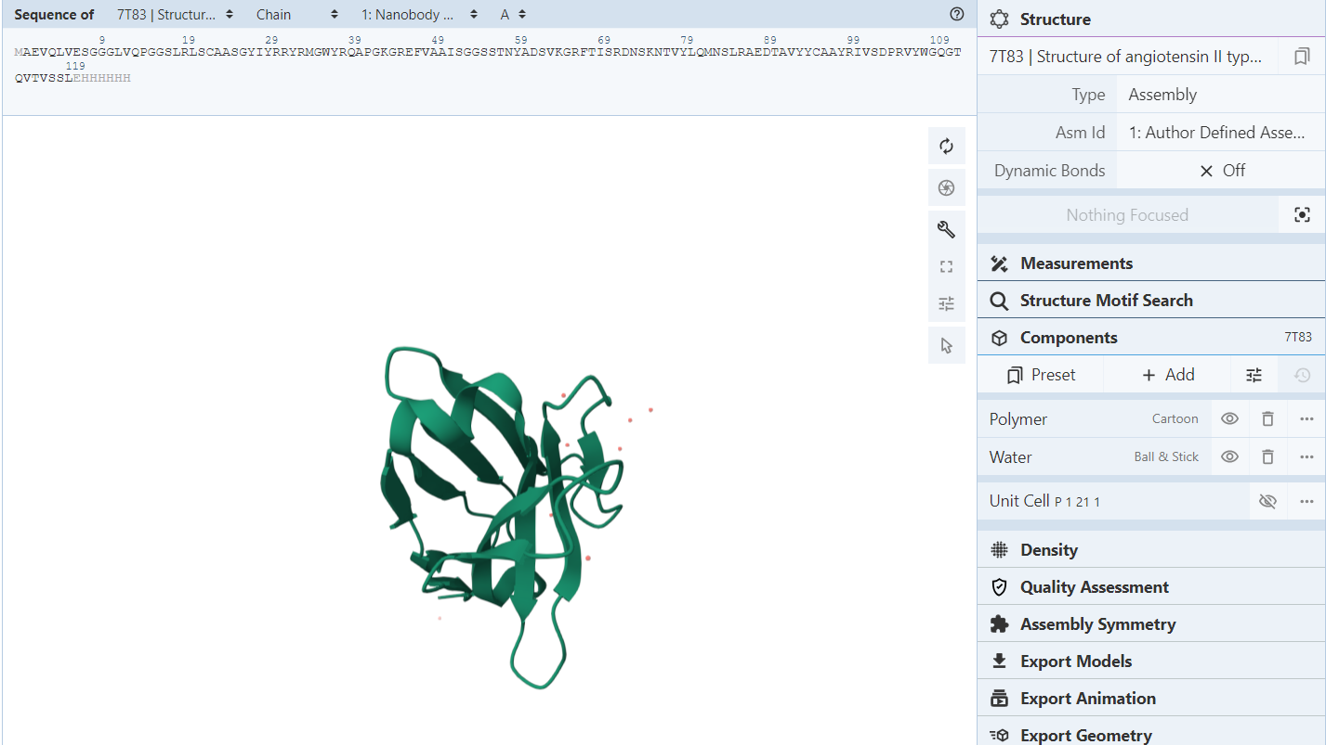

Sequence annotation and its interaction

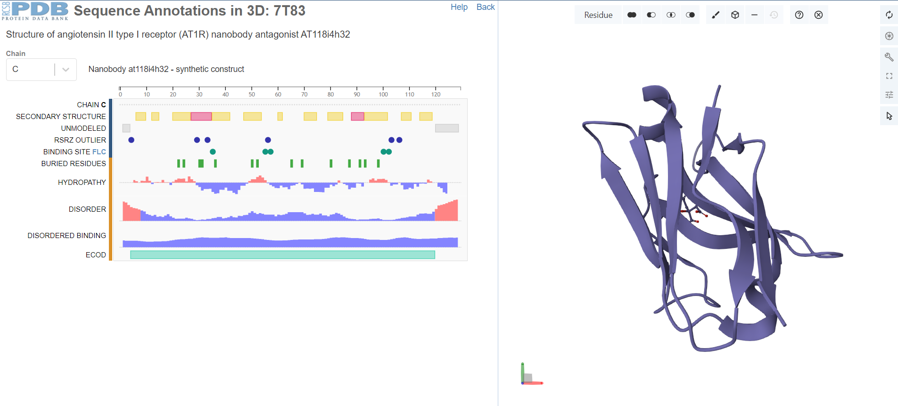

Ligand interaction

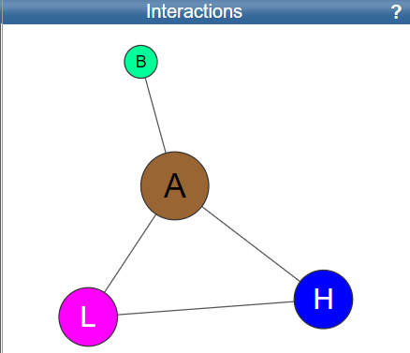

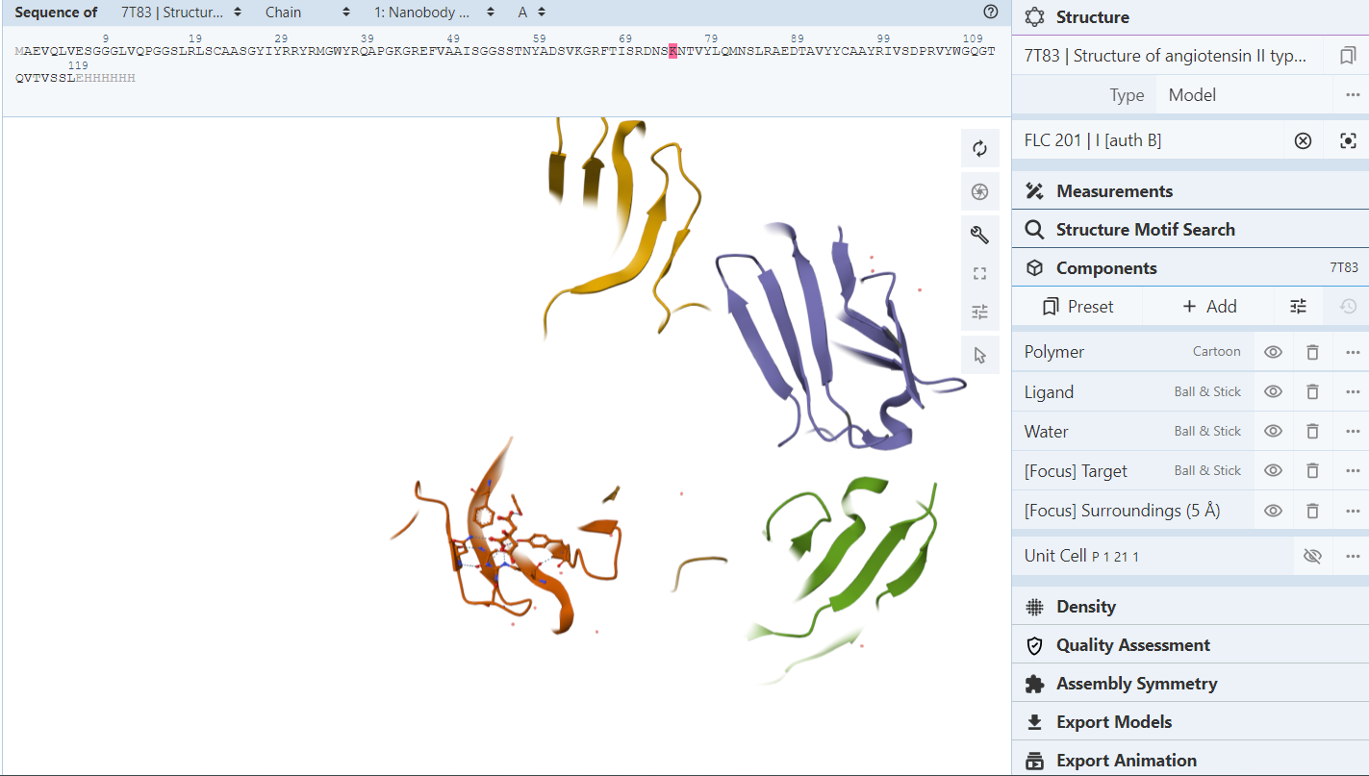

Domains

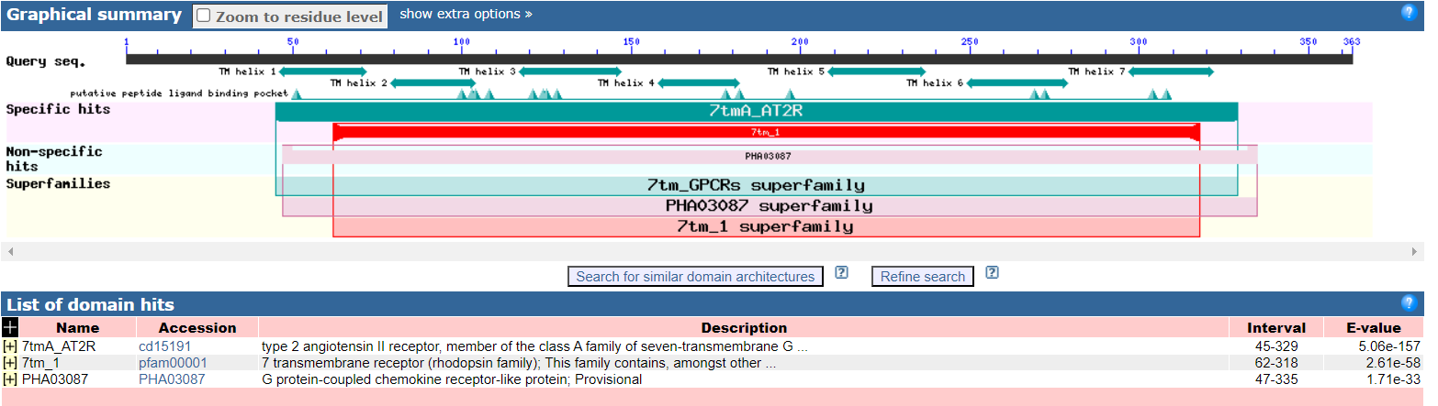

Interaction region of the molecule

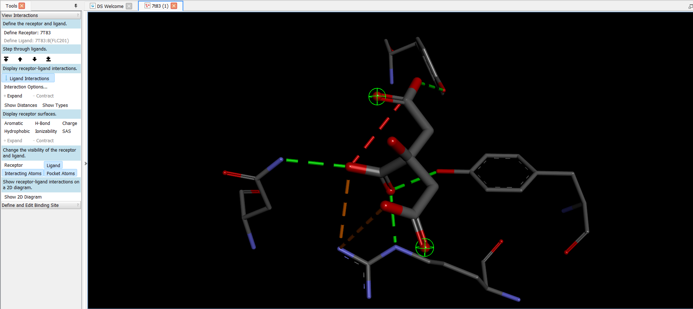

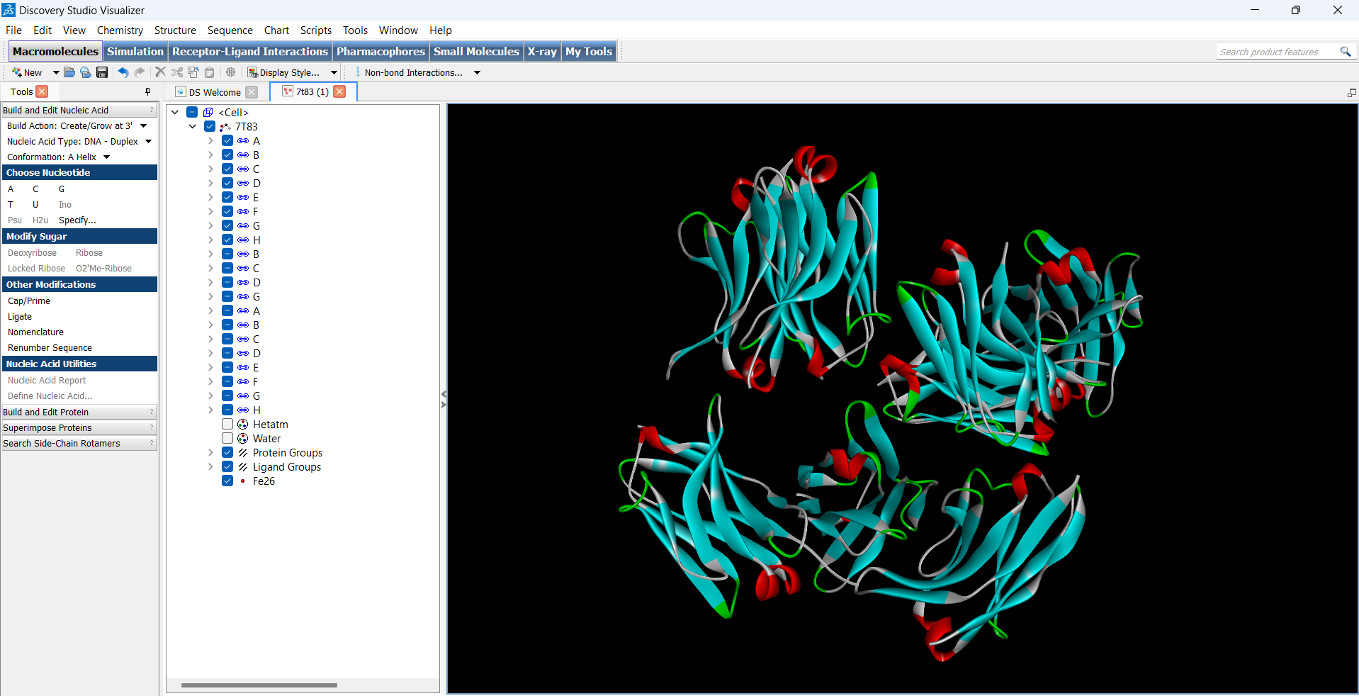

Number of chains = 20

List the natural molecule co-crystallised with the target molecule

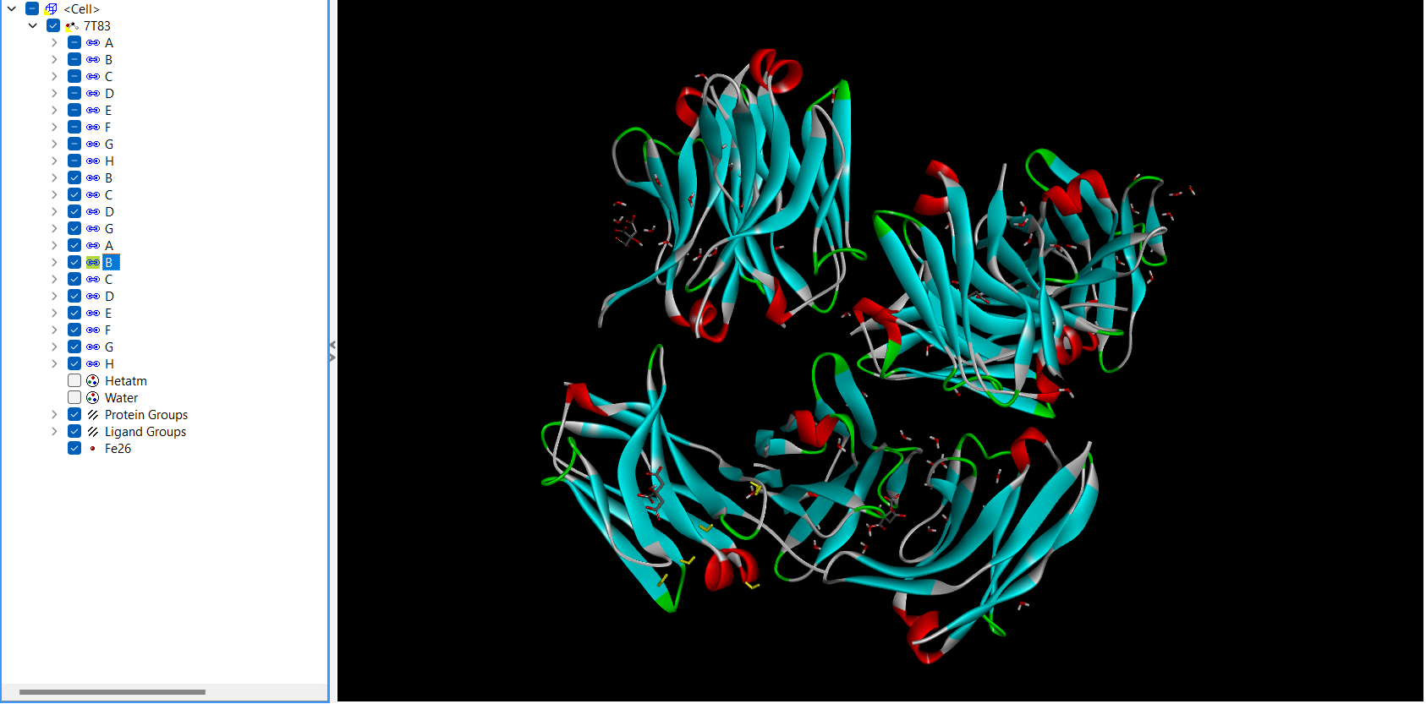

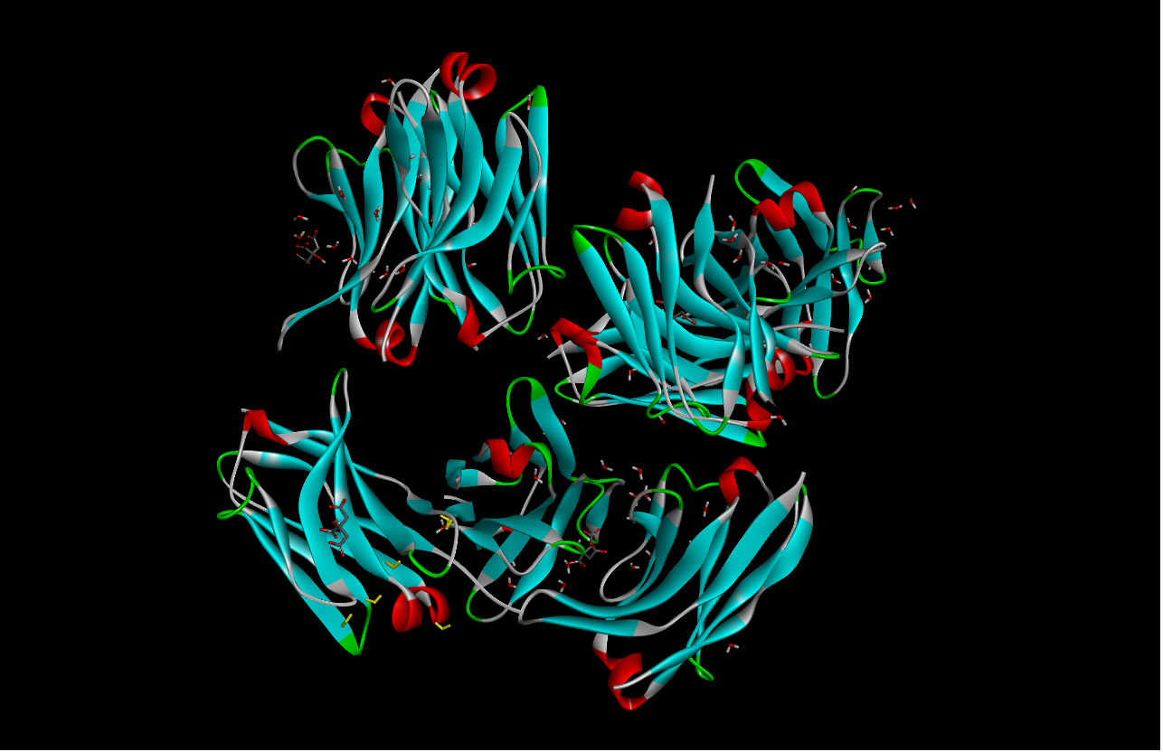

Molecule before the water molecule is removed

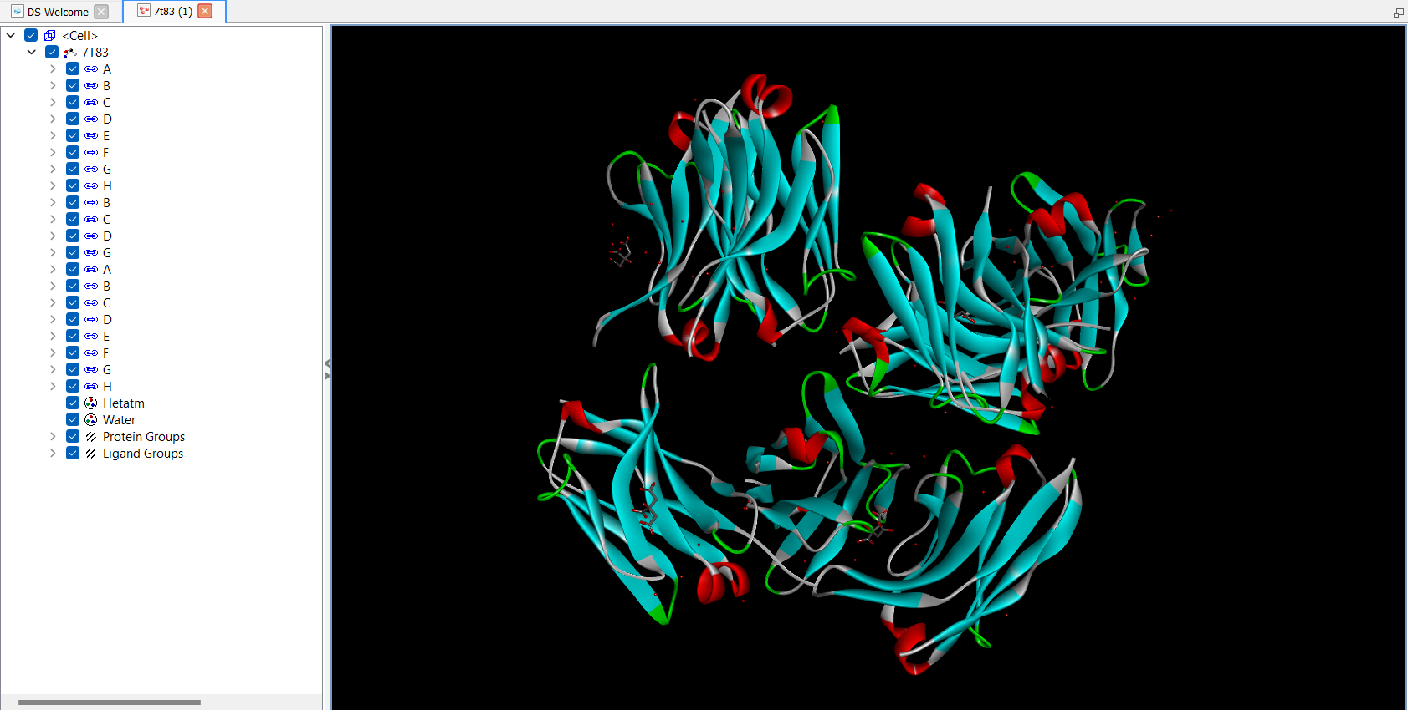

Molecule after the water molecule is removed

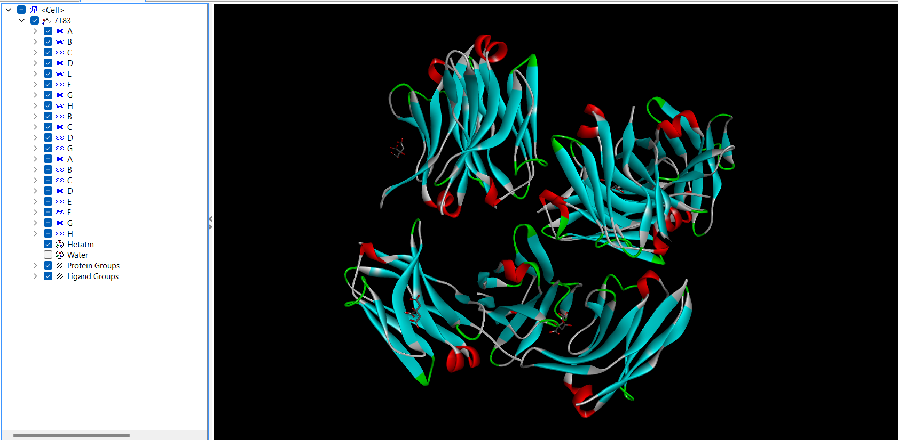

Molecule before the hetatm molecule is removed

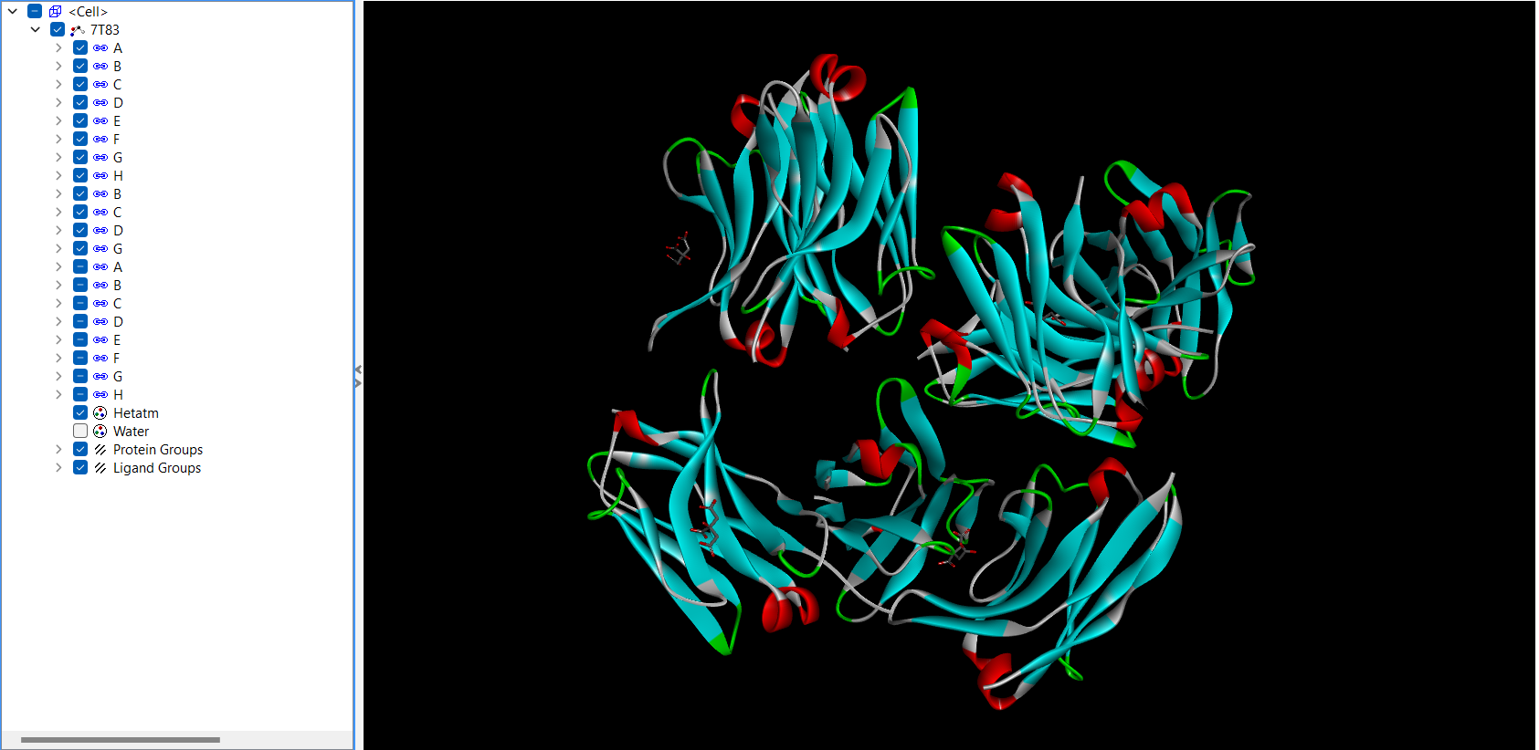

Molecule after the hetatm molecule is removed

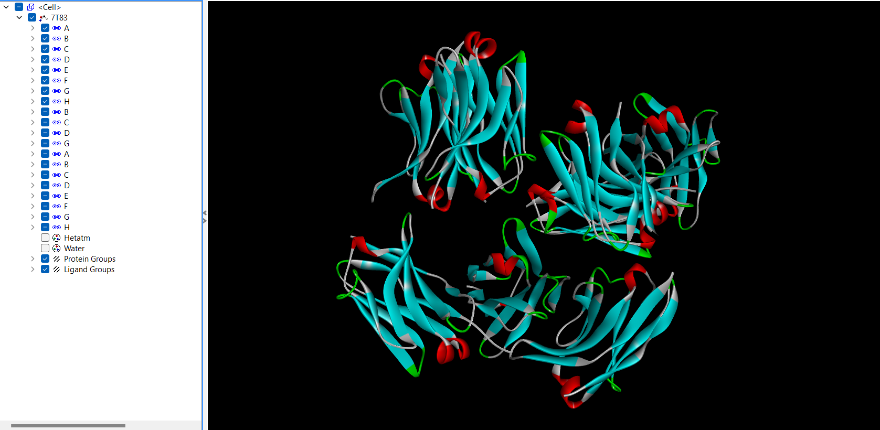

After adding polar water molecules

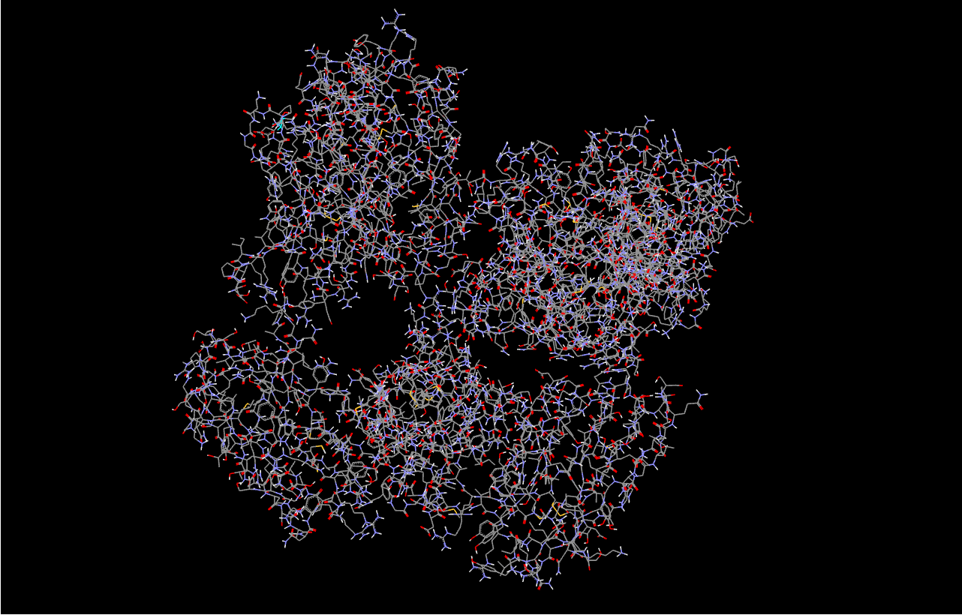

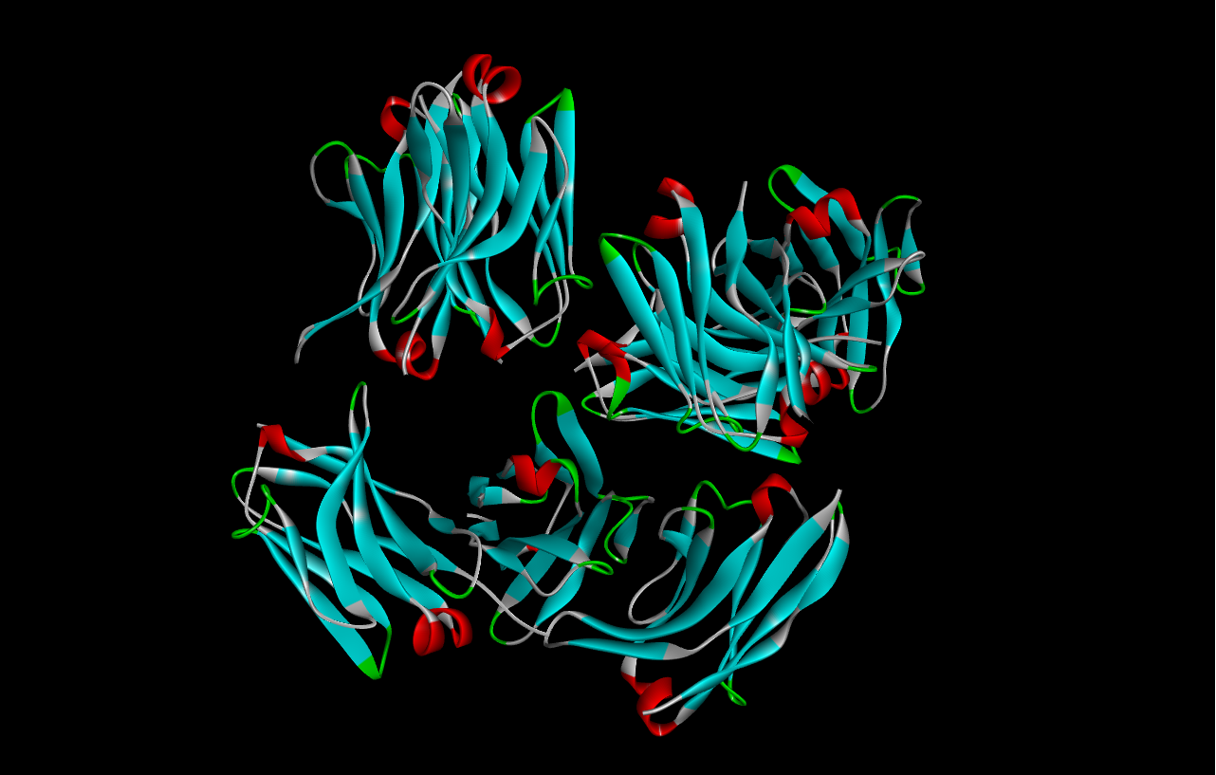

Remove chain if not required

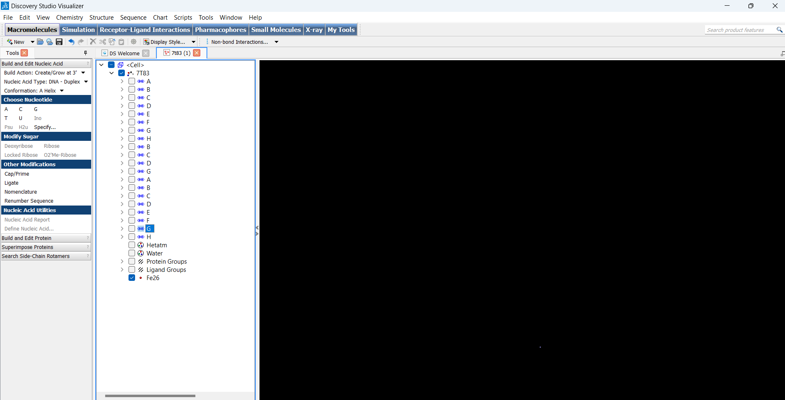

Final molecule

